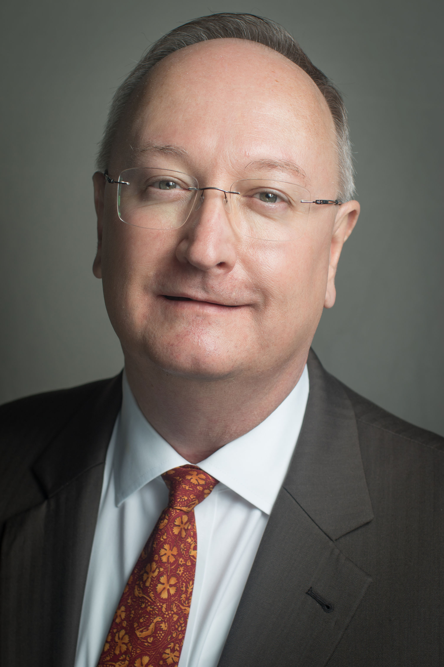 Paul A. Ledford

Paul A. Ledford grew up in Tallahassee and has lived in the area continuously since 1968. He has been involved in politics and government affairs since 1984, and has worked full time in the realm of public policy development as an association executive since 1995.

In 2004, Paul came to Florida Hospice & Palliative Care Association (FHPCA) where he serves as the President & CEO. FHPCA advocates with the legislative, executive, and judicial branches of government, operates continuing education programs, and serves as an information resource for citizens seeking end-of-life care and information. Prior to working in the association field, he served in State Government at the Department of Health & Rehabilitative Services (HRS), and the Department of Business & Professional Regulation (DBPR).

Paul is a 1986 graduate of Florida State University with a Bachelor of Science in Human Resource Management. He is a Charter Member of the Florida Association of Professional Lobbyists (2000) and is a Designated Professional Lobbyist (DLP). Paul was certified as an Advanced Care Planning Facilitator in 2007, and earned the Certified Association Executive (CAE) designation in 2009. In 2015, Paul was named the Florida Society of Association Executives “Executive of the Year,” and in 2018, FHPCA was named “Association of the Year.” He is married to his wife, Nancy, and they have two adult children, Lydia and Micah.

